

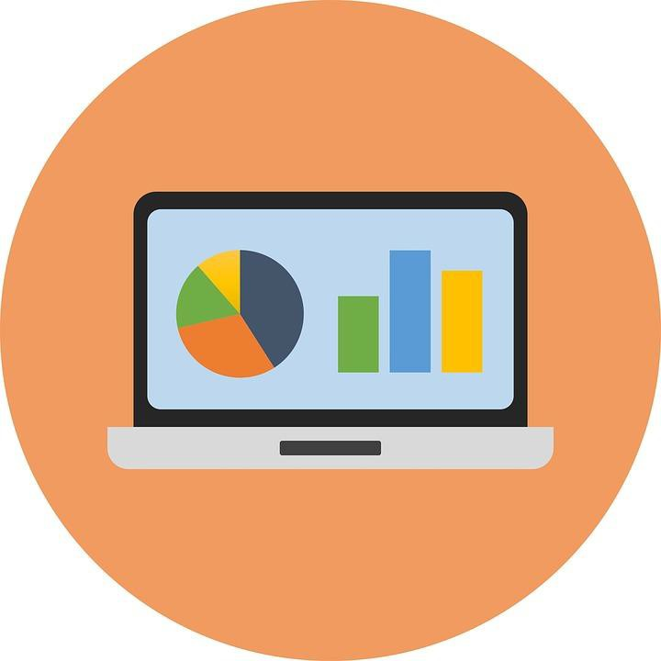**BUSINESS INTELLIGENCE**

ANALYST CHALLENGE

© Surabhi 2023

Agenda

**1 2 3**

Exploration Analysis Recommendation

1. Budget exploration of projects.
2. What is status bid requests ?
3. Analysis of subcontractors.
4. Avg time between creation of a project and creation of ﬁrst bid.
5. Conversion rates of Network & Company Subcontractors.
6. Geographical exposure of the XYZ.



© Surabhi 2023

© Priyanka Jha 2021

# 1

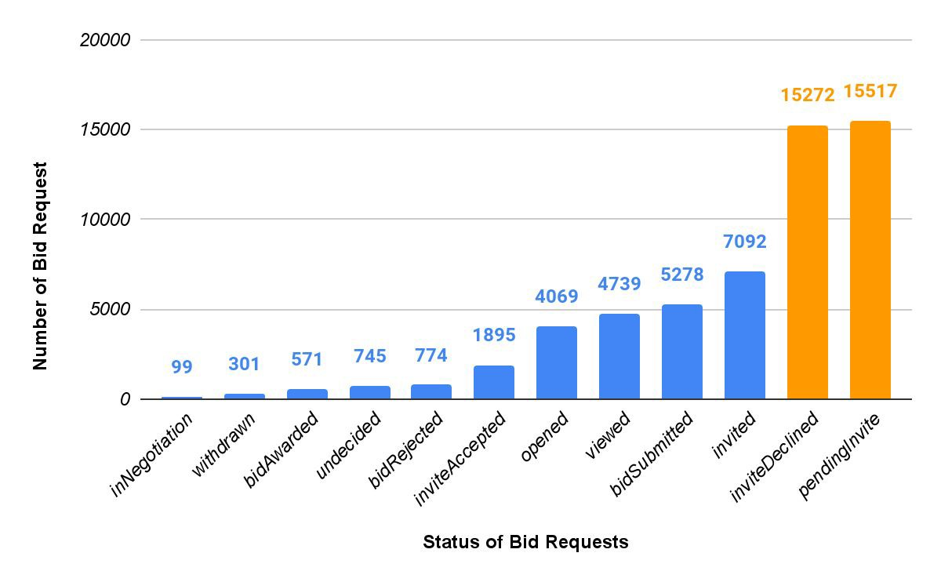

© Surabhi 2023

© Priyanka Jha 2021

What are the **STATUS** of **ALL** the bid requests?

52,500,486,443,489€

Total Budget of Bid Projects Registered

99,432,739,476€

Average Budget of Bid Projects Registered

**June** has the

**MOST**

number of registered projects,

while **November** has the **LEAST**.



© Surabhi 2023

The **BIGGEST** Reasons of

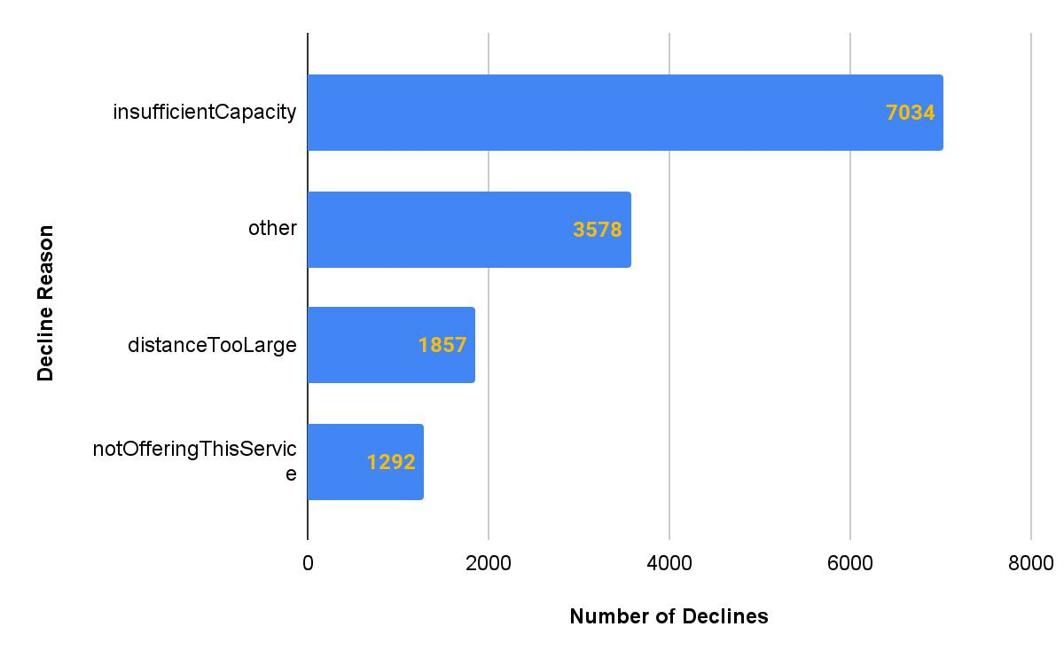

**2**

Declining

the **Bid Requests** of Subcontractors.

© Surabhi 2023

© Priyanka Jha 2021

Which **Company Size** of Subcontractors have the number of **bidAwards**?

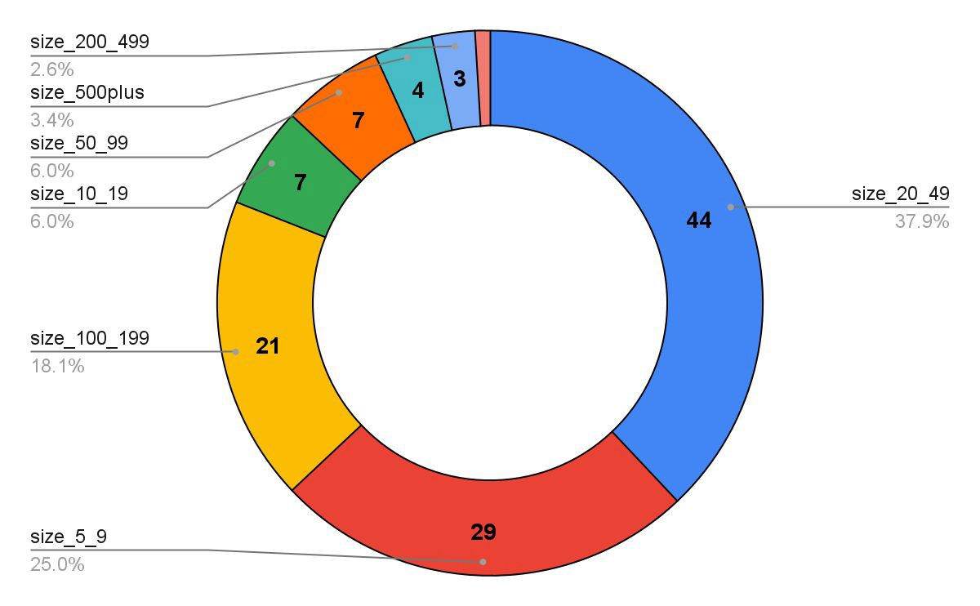

**HIGHEST**

© Surabhi 2023



**~ 74 days**

The **AVERAGE** time between the **creation of a project**

## and the creation of the ﬁrst bid request in that project?

© Surabhi 2023

The **CONVERSION RATE** of Bid Requests

**Network Subcontractors**

**Company Subcontractors**

**16.3%**

**91.8%**

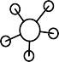

© Surabhi 2023

For **XYZ**, **Germany** is the **ONLY** country with more than **32000+**

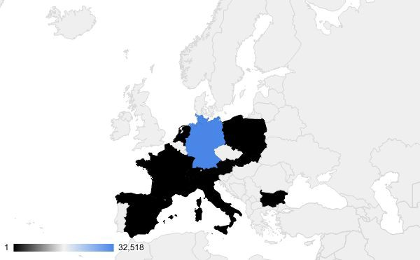

**3**

subcontractor registration.

### Austria, Switzerland, Hungry, Poland, Slovakia, Italy,

still has **a lot of potential** to **increase** number of subcontractor registration.

**Bulgaria, Czechia, Spain, France**

© Surabhi 2023

© Priyanka Jha 2021

Thanks!

***Any questions ?***

* [surabhichandran6@gmail.com](mailto:surabhichandran6@gmail.com)

© Surabhi 2023

11